There are 2 decorative screws fastening original magnified lens side of the frame onto frame assembly.

Note; the magnified lens is one assembly piece consisting of the lens attached to the finished framework rim. See image below for reference.

- Using hands, carefully remove decorative head screw on left and right hand side of frame assembly.

- Gently pull off the magnified lens assembly from frame assembly.

- Replace original magnified lens set with new magnified lens set. User can keep original.

- Align the screw holes on frame assembly to the screw holes on magnified lens set.

- Gently slide the magnified lens set onto the frame assembly. Make sure screw holes are aligned.

- Carefully refasten decorative screws on the left and right hand side of the frame assembly.

- Stowe magnified lens set removed in area away from sunlight and water.

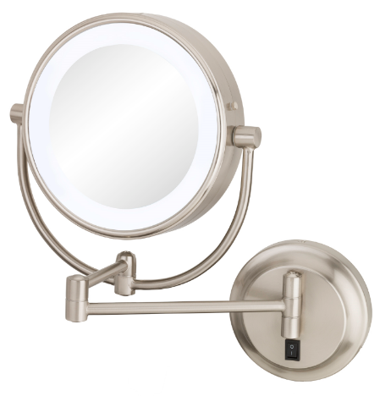
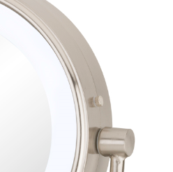
Detachable side of frame assembly
Mirror frame assembly
#1

